WAP54G
This device offers 4 modes of configuration. But you have to be careful because we cannot just set this access point into any mode without checking first for its compatibility. I will show you how to configure the device manually. Before the steps, here are the four ways this device is capable of functioning.
First as a plain Access Point, needs to be connected into a wired device (e.g. router, switch).
Second, as a Repeater, now you have to take note that it only works as a repeater with another linksys wireless router, not any wireless router but specifically WRT54G all versions.
Another configurations, Access Point Client and as a Wireless Bridge, also take note that when set to “AP Client” and “Wireless Bridge” mode, this device will only communicate with another Linksys Access Point (WAP54G), preferably same hardware and firmware version.
Important Note:AP Client, Wireless Repeater, and Bridging modes, make sure the SSID, channel, and Security/WEP key settings are the same for all access points. WPA will not work with an AP Client, Wireless Repeater and Wireless Bridge modes. Device IP is 192.168.1.245.
ACCESS POINT MODE - this mode allows wireless client to connect to the access point and routes traffic between the wireless and wired interface. Use this mode to create a standard wireless Infrastructure network.
By default the AP mode is set to Access Point.
1. Push the reset button while it’s powered up, release the reset button then unplug and replug the power cord.
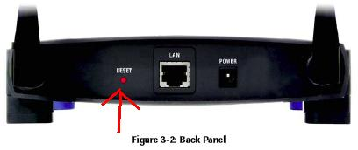
2. If your router’s IP address is 192.168.1.x, you may just hardwire your access point directly to the router and on your computer launch an Internet Explorer or any browser. On the address bar type in 192.168.1.245, type in admin as password, no username.
3. If you are configuring the device without a router or if the router has a local IP address other than 192.168.1.x, get your computer and, hardwire the access point to it and assign a static IP address, eg. 192.168.1.25. Open a browser an access 192.168.1.245 on your address bar, password is admin.
4. By default in the setup page under Network Setup, Configuration type is set to Static IP, leave it as it is or if your router has different Network settings (ex. 10.10.10.1), you may change the IP address following the range of your existing network (10.10.10.245), default gateway should be the IP address of your router, save settings. Click now on AP MODE subtab, select on Access Point and save the settings.
5. Click now on Wireless and configure your wireless settings (WIRELESS SECURITY subtab and select the desired encryption (WEP, WPA-Personal, WPA2-Personal, WPA2-mixed, WPA-enterprise, RADIUS), these are the security supported on the latest version releases. Take note of your encryption and of course save the settings. Turn off the access point and unplug it from the computer, set the computer’s IP address back to Obtain. Connect the access point to your router/switch regular port and power it up. It’s ready now for testing. Should there be any problem, try to powercycle the whole network (modem-router-access point).
Wireless Repeater - This mode will turn the access point into a wireless repeater. Enter the wireless MAC address of the access point whose signal you would like to repeat.
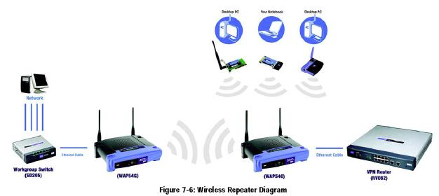
- Do the same things you did in setting the device to AP but this time on the AP Mode tab, select on WIRELESS REPEATER radio button and make sure you know the WIRELESS MAC ADDRESS of your router or another WAP54G (STATUS tab > Wireless) since you need to input that in the blank field alloted. Save the settings and check if you can connect.
AP Client - this will allow the device to act as a wireless client. You can enter the Wireless MAC address of the Access Point or use the Site Survey button to select the Access Point you want to connect.
- Under the AP Mode tab, select AP Client and push on the Site Survey button to check for the wireless network you want to connect and select it, automatically it will copy its Wireless MAC or you can manually type in the wireless mac of your network source.
Wireless Bridge - This is to create a wireless connection between two or more wired networks. This mode connects the physically separated, wired network using multiple access points. Wireless clients will not be able to connect to the access point in this mode. Enter the wireless MAC address of the wireless access points that you would like to bridge together.
- Know the Wireless MAC of your other Access Point and input it on the blank field. And do the same thing to the other WAP, they just change Wireless MAC to ensure that they only recognize each other. No intrusion from another network.
That’s it!! If you are having hard time connecting after configuring everything, make sure you perform a complete power cycle.

